G. Rupa Manasa 20-12-2023

Python Coding Assessment

**1.Explain Python Module with examples**

**a. Import module in Python**

**b. Renaming the Python module**

A Python module is a file containing Python code, typically with a .py extension, that can define variables, functions, and classes for use in other Python scripts or modules.

Modules provide a way to organize and reuse code by encapsulating related functionality into separate files.

myModule.py module is created. (creation of module)

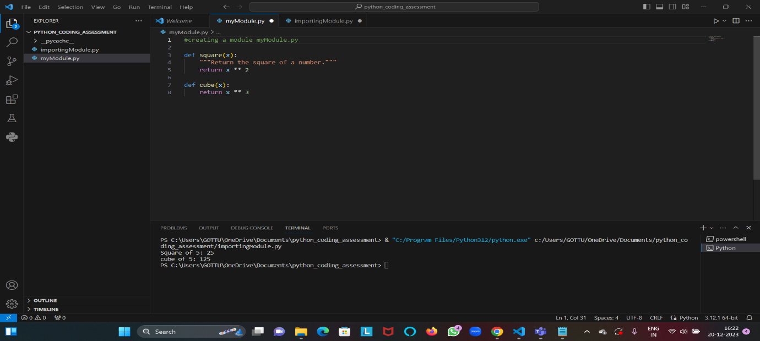

Importing the module i.e. myModule.py

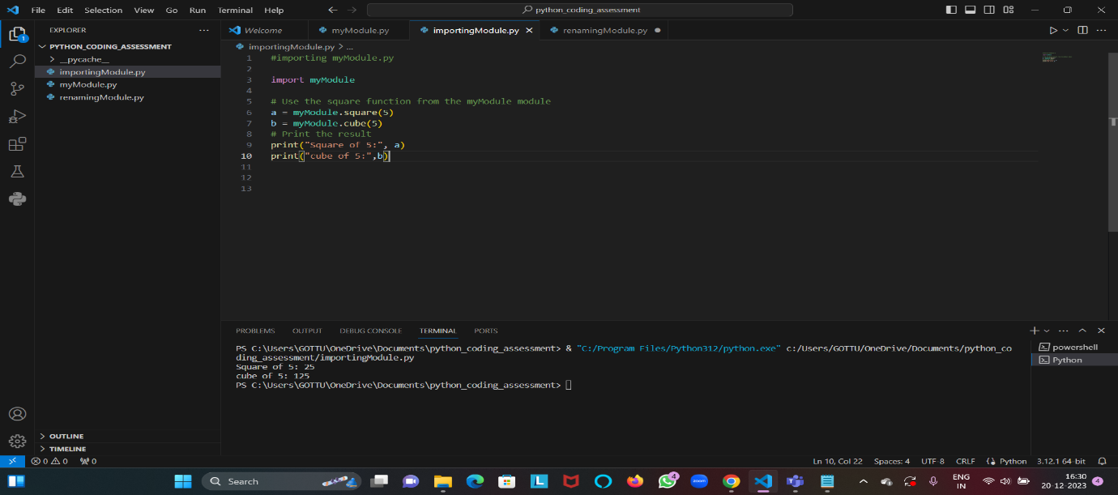

Renaming the module myModule as mm

Syntax: Import Module_name as Alias_name

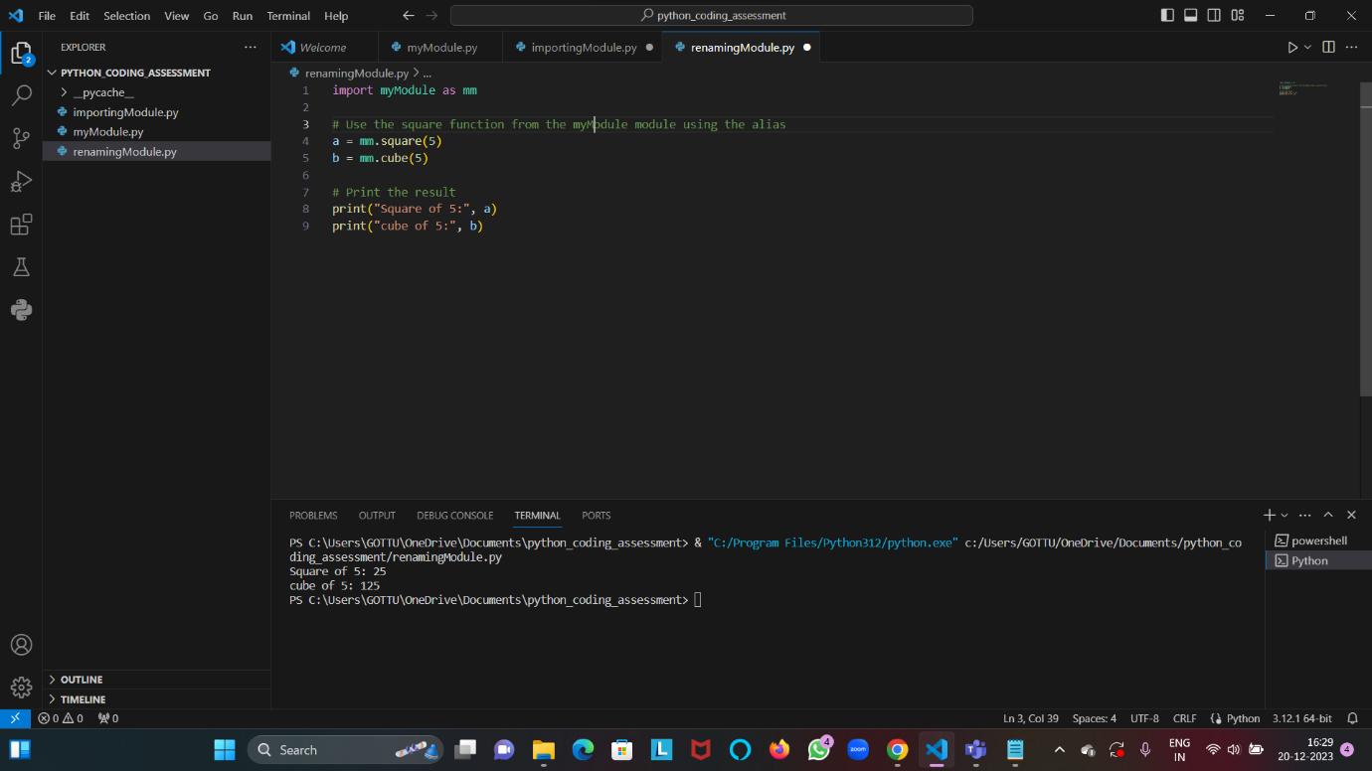

**2.Explain Pandas and numpy using Examples in PYTHON**

**Pandas** is a popular open-source Python library for data manipulation and analysis. It provides high-performance, easy-to-use data structures, and data analysis tools.

For pandas installation use the command py -m pip install pandas

**Writing data using Pandas in Python:**

Import pandas library.

Create a pandas dataframe and display.

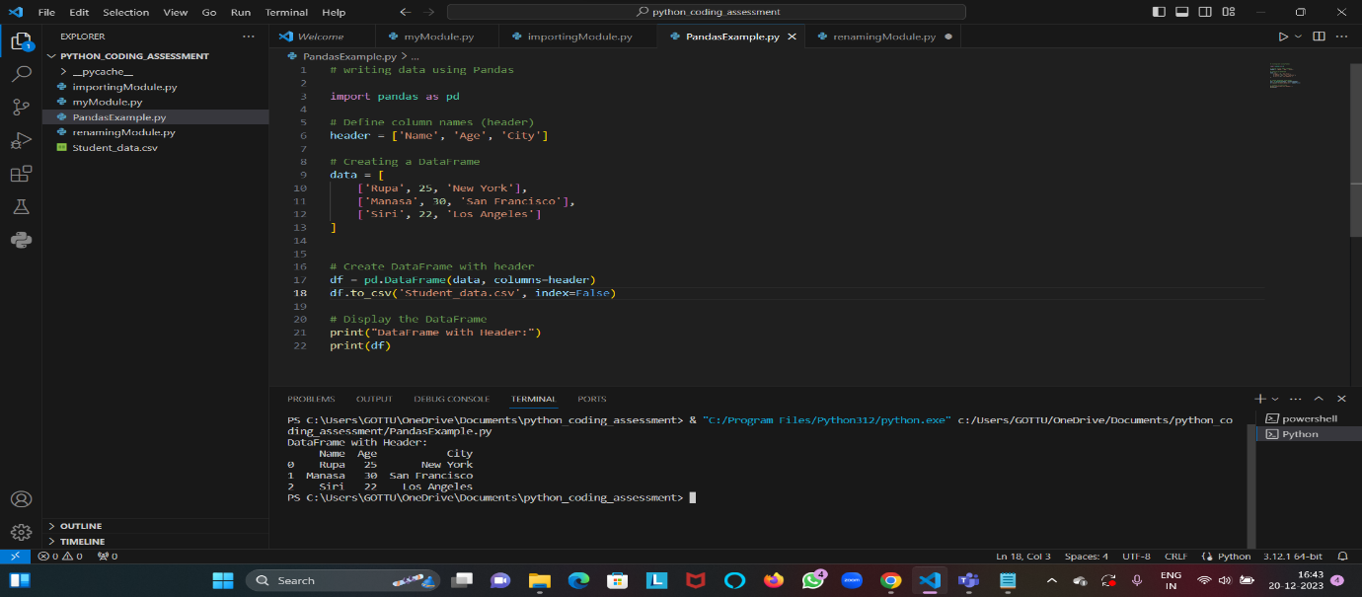

We can check the csv file in notepad.

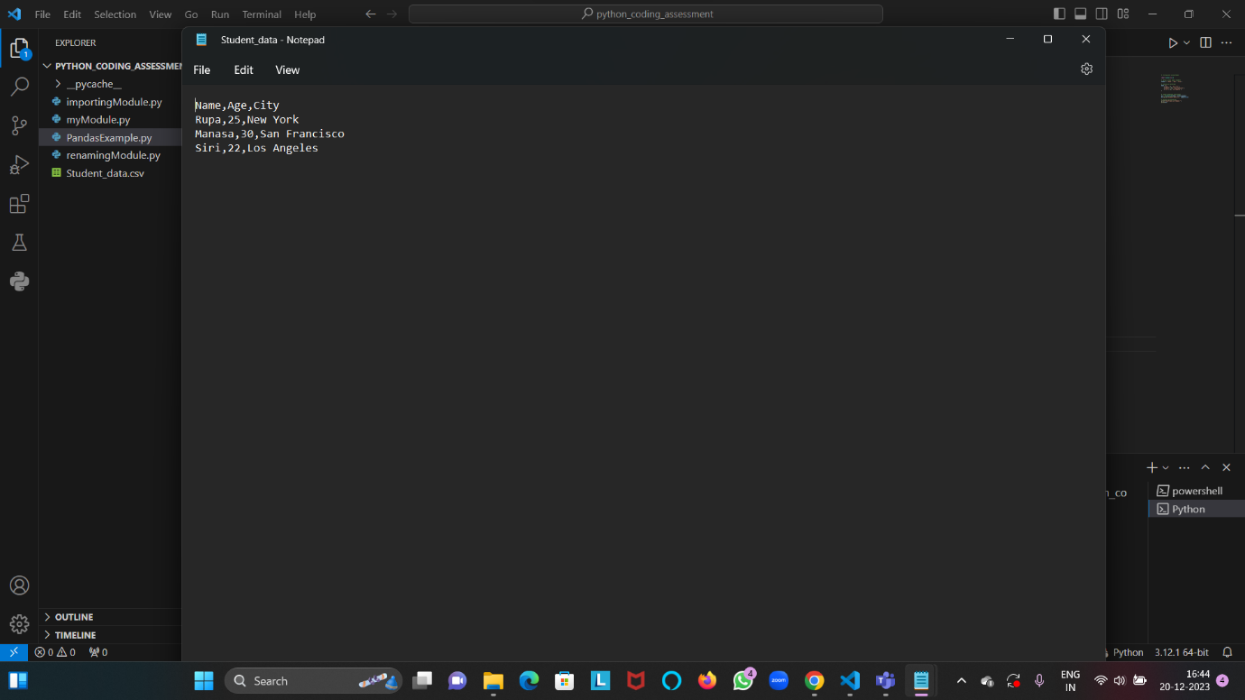

**Read data or csv file using Pandas:**

Import pandas library.

Load csv file

Display the data

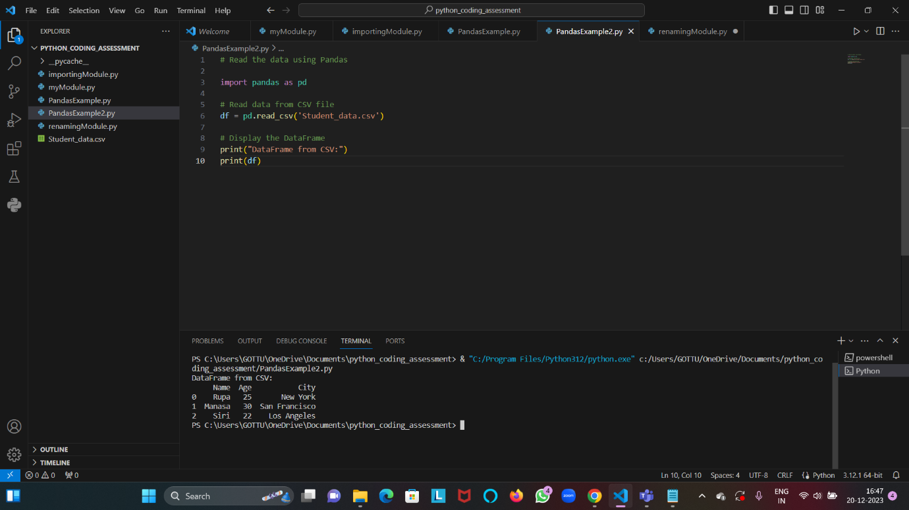

**NumPy** is a powerful Python library for numerical and mathematical operations. It provides support for large, multi-dimensional arrays and matrices, along with a collection of mathematical functions to operate on these elements.

**Creation of arrays:**

Creating 1D array, 2D array, array of zeros and array of ones.

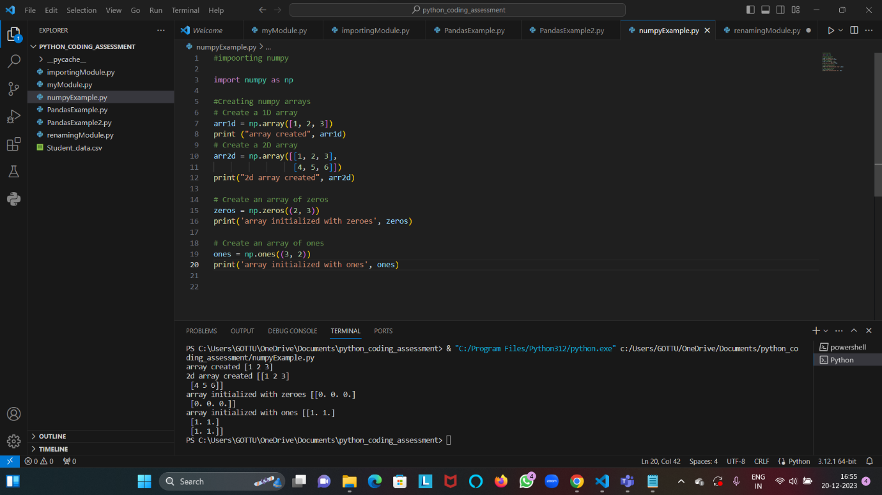

Creating Linspace array, random array

Checking type of array, shape, dimension and size of array

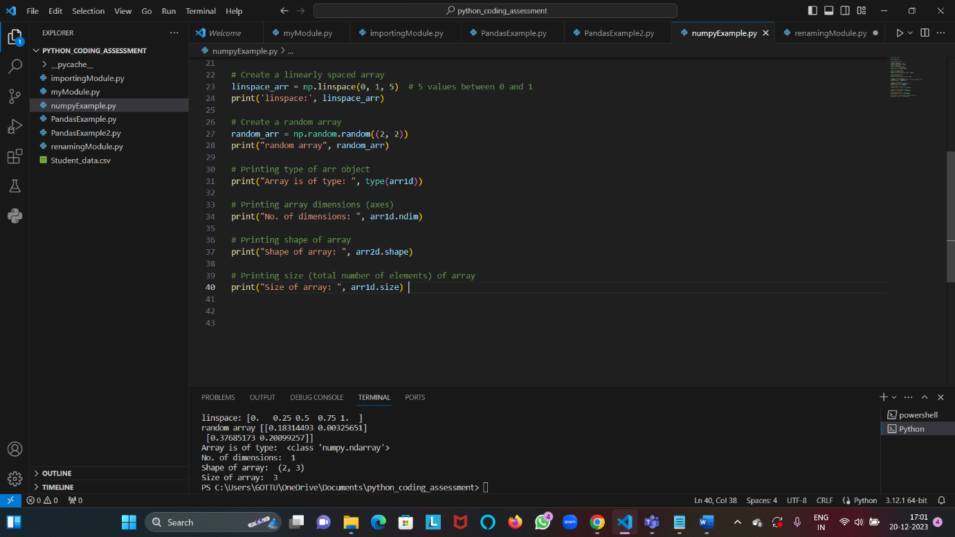

**Reshaping and flattening the arrays:**

Reshaping refers to changing the shape (dimensions) of an array while preserving the total number of elements. The reshape() method is commonly used for this purpose.

Flattening refers to converting a multi-dimensional array into a one-dimensional array. The flatten() is used.

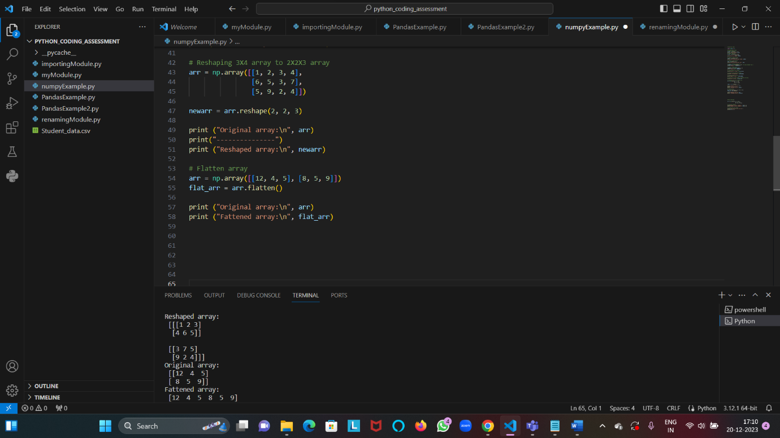

**Array indexing:**

array indexing refers to the process of accessing elements or subsets of elements from an array. Array indexing in NumPy is similar to Python list indexing but with additional capabilities for multi-dimensional arrays.

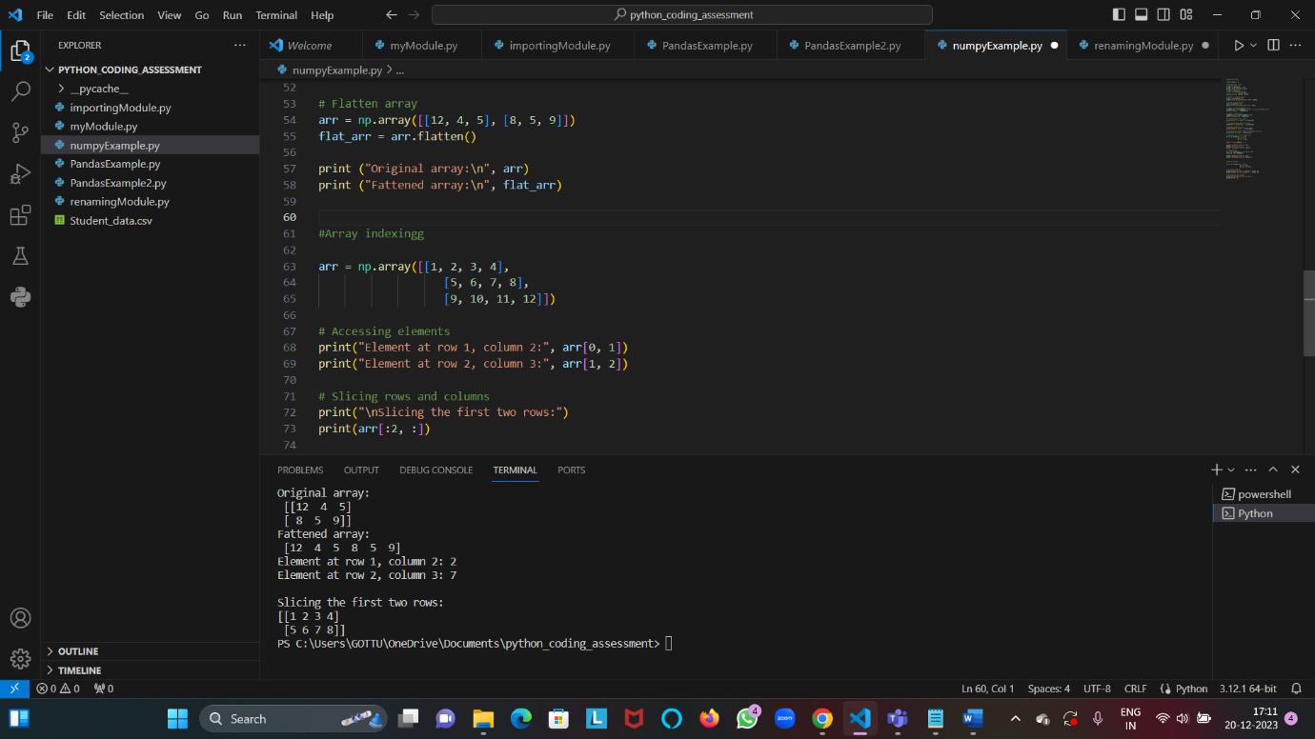

**Numpy Operations:**

Binary Operations- refer to mathematical operations that involve two arrays.

Involves Addition, subtraction, multiplication and division

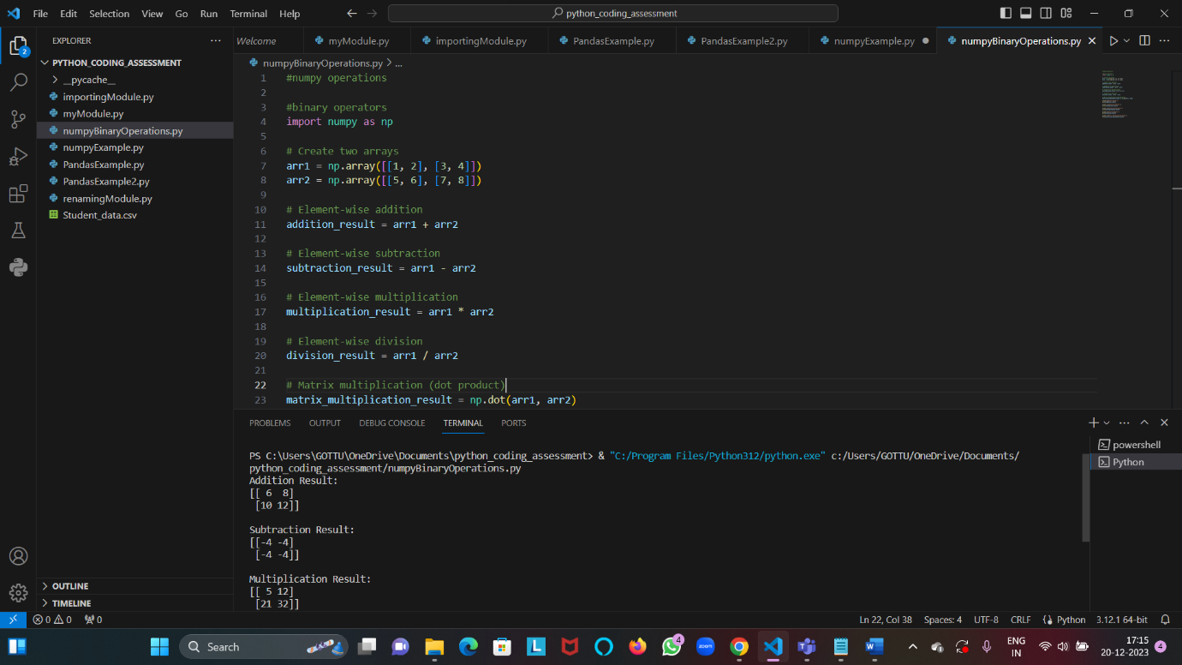

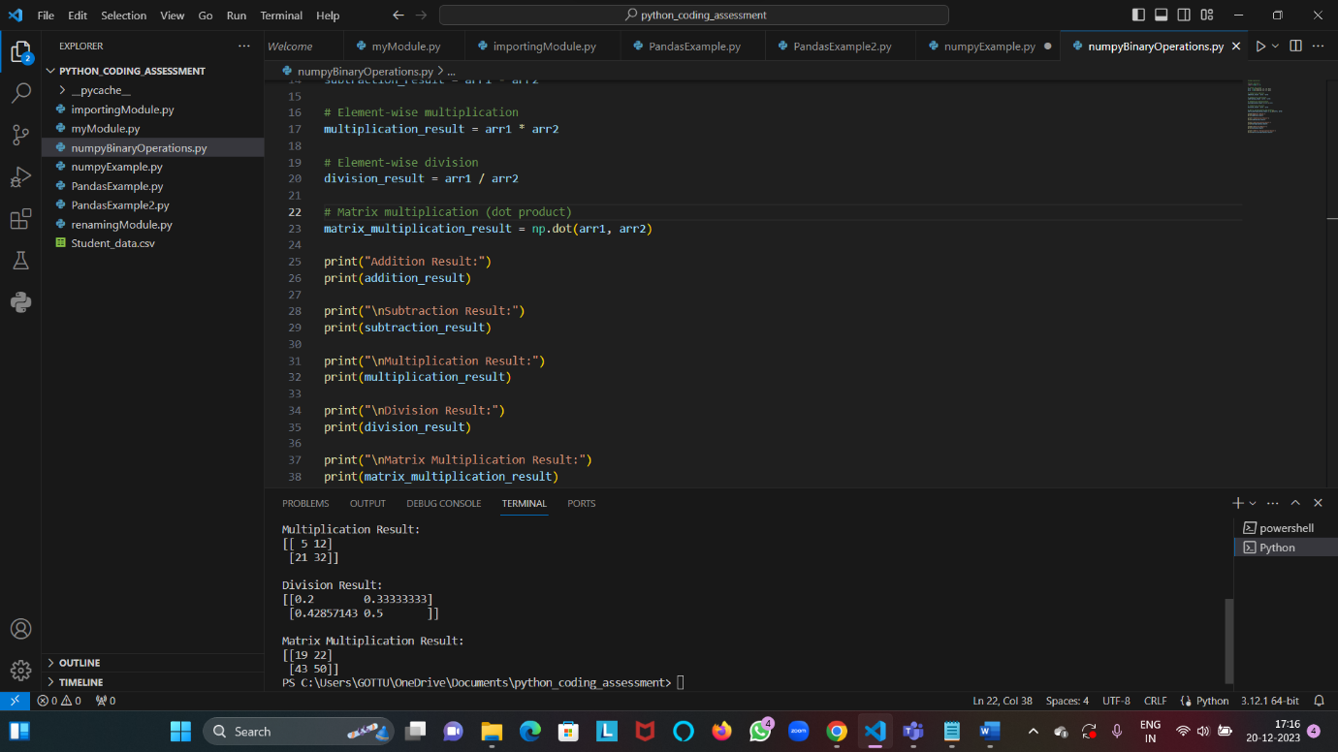

Unary Operators- involves sum(), min(), max() operators

